**Data Flow Diagrams:**

Project Design Phase-II

Data Flow Diagram & User Stories

|  |  |
| --- | --- |
| Date | 16 October 2022 |
| Team ID | PNT2022TMID28350 |
| Project Name | Project - Customer Care Registry |
| Maximum Marks | 4 Marks |

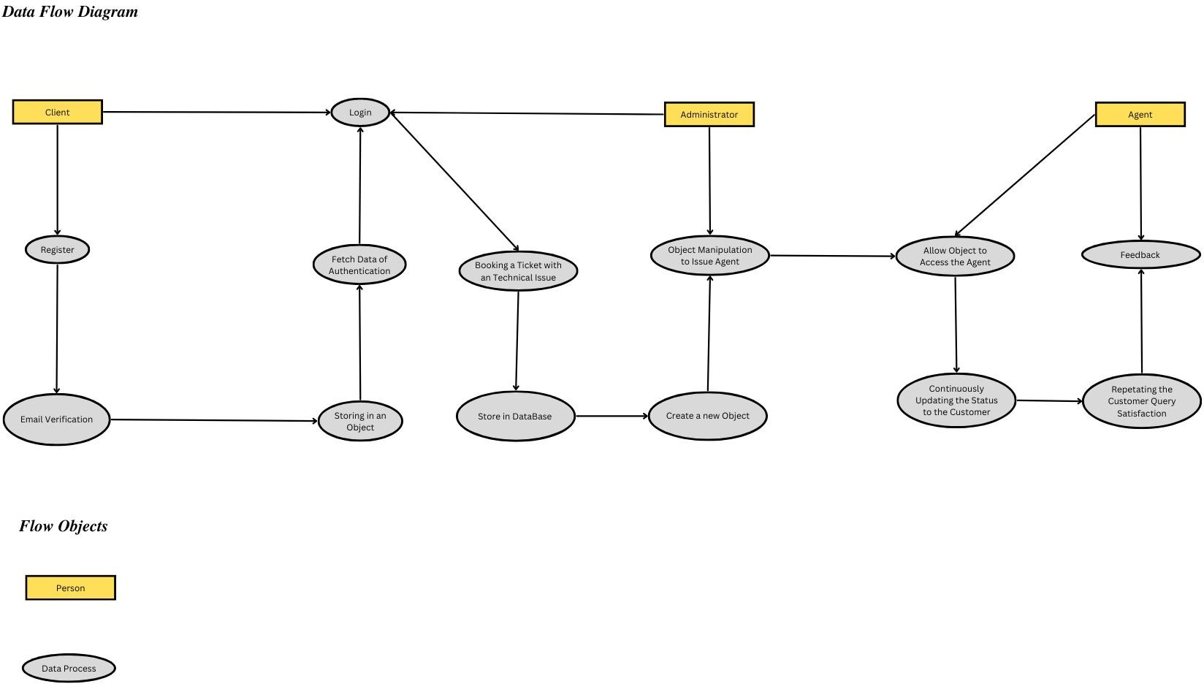

**User Stories**

|  |  |  |  |  |  |  |
| --- | --- | --- | --- | --- | --- | --- |
| **User Type** | **Functional Requirement**  **(Epic)** | **User Story Number** | **User Story / Task** | **Acceptance criteria** | **Priority** | **Release** |
| Customer (Client User) | Registration | USN-1 | As a User, I will register for the application  by entering my email, password, and confirming my password. | I will be redirected to Email Verification | High | Sprint-1 |
| Customer(Automated User) | Registration | USN-2 | As a User, I will Validate the Customer Credentials once after the Email  Verification. | I will receive confirmation Message from  Administrator | High | Sprint-2 |
| Customer(Automated User) | Registration | USN-3 | As a User, I will issue the Customer with Login Id and Password through Object Creation from the Customer Credentials. | I can register & access the dashboard with Facebook Login | Medium | Sprint-1 |
| Customer(Client User) | Login | USN-4 | As a User,I will Login into the Portal using Login Credentials Provided. | I will be Redirected to the Portal Dashboard Page | Medium | Sprint-2 |
| Customer (Mobile User) | Dashboard | USN-5 | As a User,I will book for a ticket from available sections along the Application  and Submit the Ticket to the Portal | I will be Issued with a Ticket Applied Message  from the Portal. | High | Sprint-3 |
| Customer (Admin User) | Validation | USN-6 | As a User,I will issue with a Suitable Agent to the Customer and provide a Bot Connectivity with the Agent. | I will send a mail about the agent issued to the application. | High | Sprint-2 |
| Customer(Automated User) | Bot Connected | USN-7 | As a User,I will connect the Bot to the  Customer and provide with repeated Status of the Query to the Customer | I will Receive Message  from the Responsive Server Bot. | Low | Sprint-4 |
| Customer(Agent User) | Agent | USN-8 | As a User,I will satisfy all the queries to the Customer for all the repetitive responses  from the Customers. | I will communicate with a Query from the Server  Bot. | Medium | Sprint-3 |
| Customer(Server User) | Feedback | USN-9 | As a User,I will fill up the Feedback form provided to improve or service provided from the Application. | I will accept the Feeback and issue with a message for queries | High | Sprint-4 |
| Customer(Application User) | Log out | USN-10 | As a User,I will Log out of the Application  when my Queries are over or else will begin again from the Beginning. | I will Estimate the User  Response and React to end the Process. | Low | Sprint-1 |